**ANAND SUMMER SCHOOL**

**Course Name: Utility Projects Based on Design & Simulation**

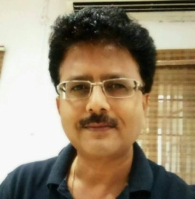

**Mentor:**

**Er. Pramil Sinha**

**Ex. IES, Ministry Of Defence**

**M.Tech (Power Apparatus & Systems, IIT Bombay)**

**Experience - 06 Years (Academics) 25 Years (Industries)**

**Head of Department of Electrical Engineering, Anand-ICE**

**Co-Mentors:**

**1. Mr. Anupam Agarwal , Astt Prof. Anand-ICE**

**2. Mr. Ajit, Astt Prof. Anand-ICE**

**3. Mr. Uttam Gupta, Astt Prof. Anand-ICE**

**Objective & Details:**

**To create utility projects addressing the common problems, or explaining any science phenomenon using a suitable freely available software such as EVERY CIRCUITS.**

**Outcomes of the Course:**

**Students will be able to use the software effectively for study and applications in future. Embibe problem solving approach among students. Understanding basic concepts of design and simulation to obtain solution to a problem.**

**Course Duration: 15 Hours( 90 minutes session on each day for 10 days)**